IP AND SUBNETTING EXERCISES

1. Write the subnet, broadcast address and valid host range for the following:
   1. 192.168.100.17, with 4 bits of subnetting

Is a class C

11111111.11111111.11111111.11110000 🡪255.255.255.240

turning the last 8º into binary: 192.168.100.00010001

4 bits: 192.168.100.00010000🡪192.168.100.16

192.168.100.00011111🡪192.168.100.31

192.168.100.17🡪192.168.100.30

* 1. 192.168.100.66, with 3 bits of subnetting

Is a class C

we add 3 bits: 11111111.11111111.11111111.1110000🡪255.255.255.224

192.168.100.01000000🡪 192.168.100.64

192.168.100.01011111🡪 192.168.100.95

* 1. 172.16.10.5/20

Is a class B

11111111.11111111.11110000.00000000

172.16.10.5🡪 172.16.00001010.00000101

172.16.00000000.00000000🡪 172.16.0.0

172.16.00001111.11111111🡪 172.16.15.255

d. 172.16.10.33/255.255.252.0

1. You have been asked to create a subnet that supports 126 hosts. What subnet mask is the most efficient one? $2^{n}-2=126{ 2}^{7}-2=126$

7bits 🡪hosts in the mask 11111111.11111111.11111111.10000000

subnet mask is 255.255.255.128

1. Given the following
   1. Network address: 192.168.10.0

b. Subnet mask: 255.255.255.192

How many subnets are there? How many hosts? What are the valid subnets?

1. What is the problem in this Network?

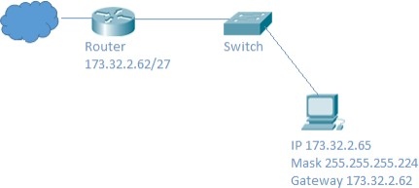

1. XYZ Company would like to subnet its network so that there are five separate subnets. They will need 25 computers in each subnet. Complete the following table: NOTE: If you create more than five subnets, list the extra ones too.

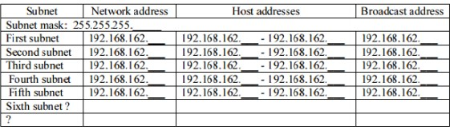

1. Imagine we want to create 1000 subnets with a /8 private network. Calculate the mask and the first, second, penultimate and last networks you would obtain.